**Kien Vu Homework 2 ISYE6400**

**Problem 1:** k-out-of-n system

Probability of a component working when checking at time t = 3 months, assuming n =8, k=4, r=3/2 and **λ = 1/10=> p= exp{-0.1t3/2}**

1. Probability that a k-out-of-n system is still operation when checked at time t =3:

**P(X>=4) = $\sum_{k=4}^{8}{\left(\begin{matrix}8 \\ k\end{matrix}\right)p^{k}}{(1-p)}^{8-k}$ = 0.5351**

1. Probability that a 5-out-of-n system is still operation when checked at time t =3:

**P(X==5) = $\left(\begin{matrix}8 \\ 5\end{matrix}\right)p^{5}{(1-p)}^{3}$ = 0.2773**

Probability that exact 5 components working while the system working when checked at time t

**P(x==5|X>=4) = P(X==5)/P(X>=4) = 0.2773/0.5351 = 0.5182**

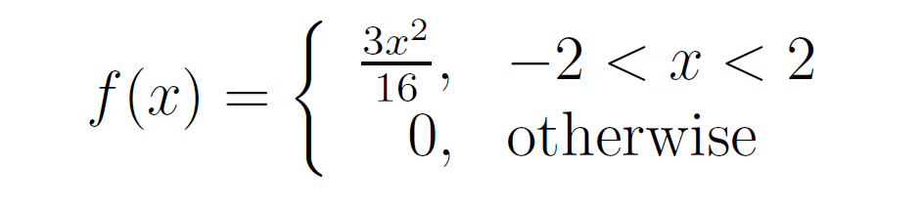**Problem 2:**

1. Probability that a randomly chosen measurement can be classified as accurate (abs(X) < 0.5)

**P(abs(X)<0.5) = $\int_{-0.5}^{0.5}{f(x)}dx$ = $\frac{3}{16}\int_{-0.5}^{0.5}{x^{2}}dx$ = $\frac{3}{16}{}_{-0.5}^{0.5}{({\frac{x}{3}}^{3})}$ = 0.015625**

1. Cumulative distribution F(x) = $\int_{-2}^{2}{f(x)}dx$ **= $\frac{3}{16}\int_{-2}^{2}{x^{2}}dx$ = $\frac{x^{3}}{16}$**
2. Expected loss (mean of Y) :

**E(Y) = E($X^{2}$) = $\int_{-2}^{2}{x^{2}f(x)}dx$**  **= $\int_{-2}^{2}{x^{2}(\frac{3}{16}x^{2})}dx$**

**E(Y) = $\frac{3}{16}\int_{-2}^{2}{x^{4}}dx$ = $\frac{3}{16*5}\left(x^{5}\right)|\begin{matrix}2 \\ -2\end{matrix}$ = 2.4**

1. Probability of Y is less than $3:

Y < $3 $\underset{→}{yields} X^{2}<\frac{3}{1000}$ $\underset{→}{yields}-\sqrt{\frac{3}{1000}}$ < X < $\sqrt{\frac{3}{1000}}$

**P(abs(X)< $\sqrt{\frac{3}{1000}}$) = $\int_{-\sqrt{\frac{3}{1000}}}^{\sqrt{\frac{3}{1000}}}{f(x)}dx$ = $\frac{3}{16}\int_{-\sqrt{\frac{3}{1000}}}^{\sqrt{\frac{3}{1000}}}{x^{2}}dx$ = $\frac{3}{16}{}_{-\sqrt{\frac{3}{1000}}}^{\sqrt{\frac{3}{1000}}}{({\frac{x}{3}}^{3})}$ = 2.054e-5**

**Problem 3:**

1. 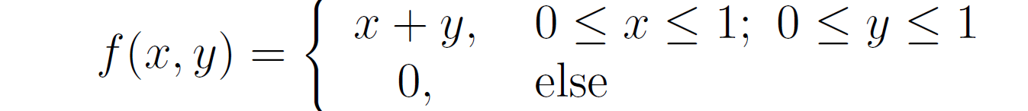Marginal distribution of $f_{X}(x)$

$$f_{X}\left(x\right)= \int_{-inf}^{inf}{f\left(x, y\right)}dy= \int_{-inf}^{0}{f\left(x, y\right)}dy+\int_{0}^{1}{f\left(x, y\right)}dy+\int_{1}^{0}{f\left(x, y\right)}dy=\int_{0}^{1}{f\left(x, y\right)}dy= \int_{0}^{1}{(x+y)}dy=\left(xy+\frac{y^{2}}{2}\right)|\begin{matrix}1 \\ 0\end{matrix}=\left(x+\frac{1}{2}\right)$$

**When 0<=x<=1, else 0**

1. Conditional distribution **f(y|x) = $\frac{f(x,y)}{f_{X}\left(x\right)}$ = $\frac{x+y}{x+\frac{1}{2}}$ when x, y in [0,1]**

**Else f(y|x) is undefined**

**Problem 4:**

$$π\left(θ | x\right)=f\left(u1, u2, …., u34 | θ\right)π\left(θ\right)= {(θ}^{-34}1)\frac{1}{θ} (θ>M)$$**Pareto family: $π\left(θ | x\right)= {(θ}^{-34}1)\frac{1}{θ} = θ^{-35}= \frac{α c^{α}}{θ^{α+1}}$ 1 ($θ>M)$**

Therefore **c = M = 0.54876 and α = 34**

1. $\tilde{θ }= \frac{cα}{α-1}= \frac{\left(0.54876\right)*34}{34-1}$**= 0.5654**

$$F\left(θ\right)≥0.95 \underset{→}{yields } \left[1-{\left(\frac{c}{θ}\right)}^{α}\right]1\left(θ>0.54876\right)≥0.95$$

$$Yield 1-{\left(\frac{0.54876}{θ}\right)}^{34}≥0.95$$

$$Yield {\left(\frac{0.54876}{θ}\right)}^{34}≤0.05$$

$$θ≥0.5993$$

**Therefore, the true value of parameter (0.6) in the credible set.**